Benjamin Horn

Artificial Intelligence

Homework 2

PROBLEM 1

From Node A to Node J

Total Cost: 20

A:

Order Removed From Open List:

('A', 0, 14, 'n/a'), ('D', 8, 4, 'A'), ('B', 12, 5, 'D'), ('C', 17, 2, 'B'), ('F', 19, 1, 'C'), ('J', 20, 0, 'F')

B:

Open List when Goal Found:

[B, 19, 5, A] [F, 24, 1, B] [E, 19, 11, D] [E, 27, 11, C] [G, 28, 28, D]

Closed List when Goal Found:

('A', 0, 14, 'n/a'), ('D', 8, 4, 'A'), ('B', 12, 5, 'D'), ('C', 17, 2, 'B'), ('F', 19, 1, 'C'), ('J', 20, 0, 'F')

Total Nodes Added to Open List: 11

PROBLEM 2

From Node A to Node J

Total Cost: 20

Differences between the two:

While both have the same path length, 10, but the bidirectional requires less operations, just 145 - compared to 418 without bidirectional. So the bidirectional search will be faster and will add fewer nodes/states to both the open and closed lists. Comparable times however.

BIDIRECTIONAL - Path Length: 10 | Operations: 145 | Open List Nodes: 29

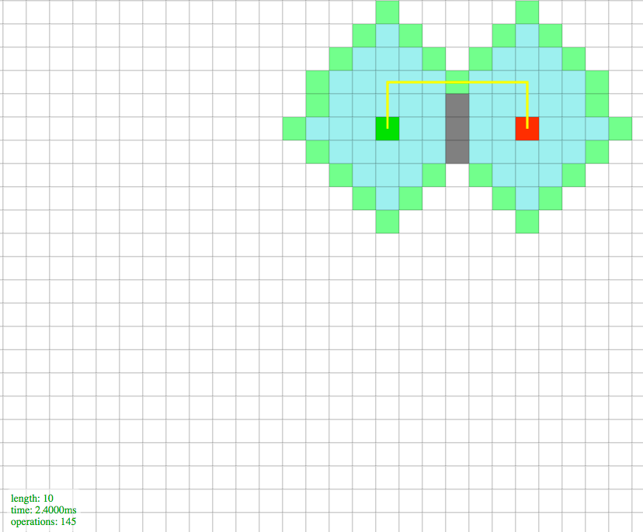

WITHOUT BIDIRECTIONAL - Path Length: 10 | Operations: 418 | Open List Nodes: 42

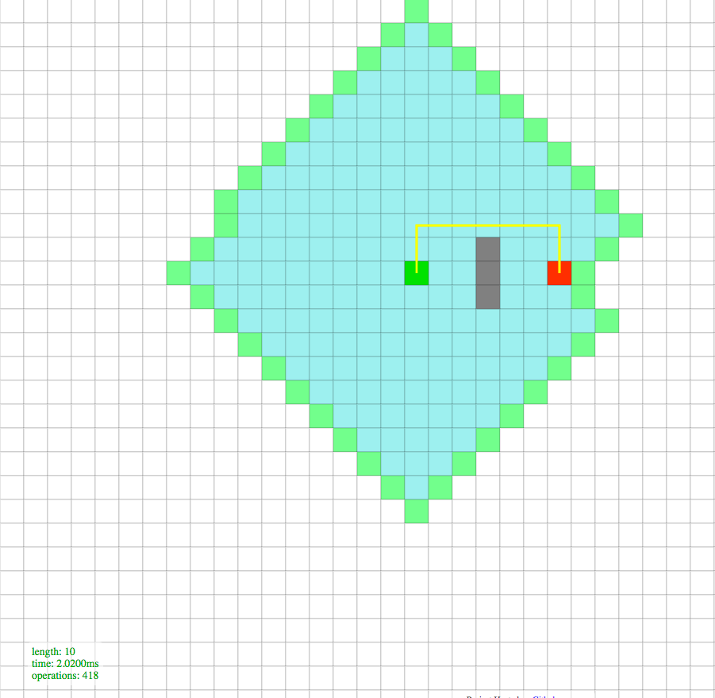

B:

Differences between the manhattan and euclidean

The Euclidean is straight line distance and Manhattan is based on x and y component distance. Both heuristic estimations give the same path length, but the Manhattan will do it in fewer operations. It also adds fewer nodes to the open and closed list than the Euclidean will. The manhattan is less operations due to these factors. The euclidean was able to run faster every time in every scenario I ran it in.

MANHATTAN - Path Length: 10.5 | Operations: 117 | Open List Nodes: 37

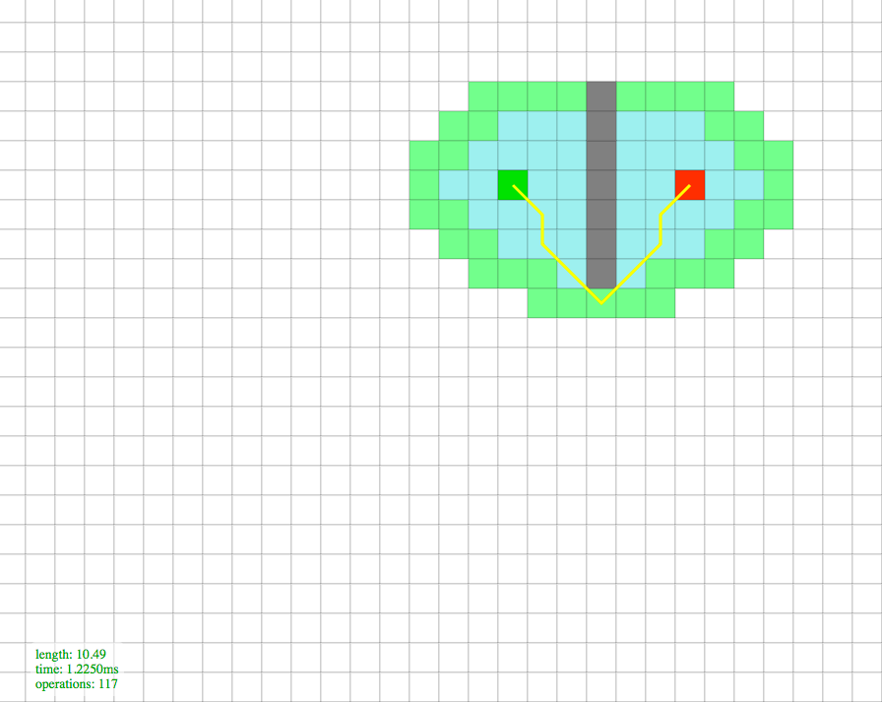

EUCLIDEAN EXAMPLE: Path Length: 10.5 | Operations: 113 | Open List Nodes: 35

